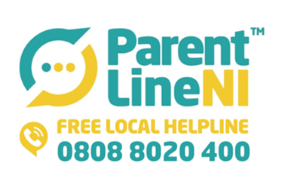

**From:** Nichola Greene <[nichola@ci-ni.org.uk](mailto:nichola@ci-ni.org.uk)>   
**Sent:** 09 January 2020 16:42  
**Subject:** ParentLine is here to support you

Dear Principal,

ParentLine NI is here to support you, your teachers, pupils and Families by offering a free confidential service.

We have created a short video for you to share on your School Open Night or at any event you feel suitable.

<https://youtu.be/iwNjuZeh_mw>

ParentLine is operated by qualified and trained counsellors.

Please feel free to contact us on 0808 8020 400 for more information.