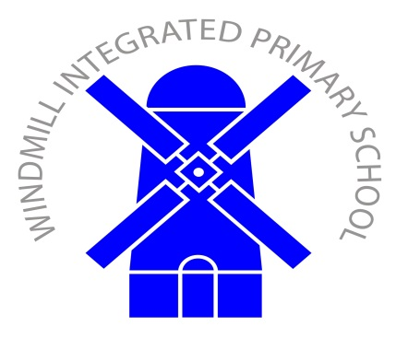 | Old Eglish Road  Dungannon  BT71 7BE  Tel: (028) 87 727277  Fax (028) 87 727610

13th May 2021

Dear Parent

It has come around again to our annual Book Fair. This will take place from Monday 17th May until Thursday 20th May. I have attached a leaflet which shows a selection of the books available to be purchased. This year our Book Fair is a 3 for 2 fair. If your child chooses 3 books, they will get the cheapest one free.

Due to Covid, unfortunately Parents will NOT be able to attend the Book Fair with their child. However, your child will visit the book fair in their class bubble. This is necessary to keep everyone safe in school.

As we are now a cashless school, payments for the Book Fair can ONLY be made online. Please use link below.

https://bookfairs.scholastic.co.uk/pay/1114678

When you have paid for the books, please fill in the Parent Order form which your child will bring home from school and return to your child’s teacher.

We as a school receive 60% commission from the money taken from the Book Fair, to spend on books. Your support for this event would be very much appreciated in these times of stretched budgets.

Kind regards,
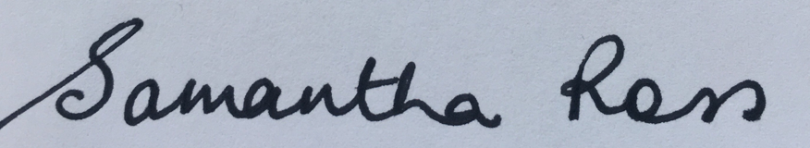

Mrs S Ross

Vice Principal and Literacy Co-ordinator

