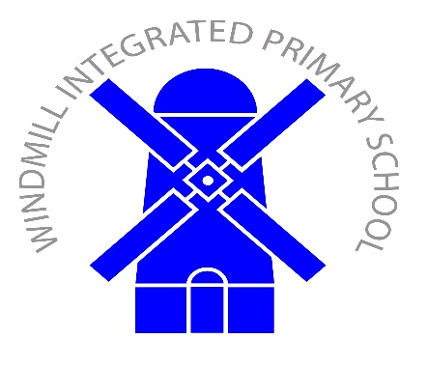 | Old Eglish Road  Dungannon  BT71 7BE  Tel: (028) 87 727277  Fax (028) 87 727610
18th October, 2021
Dear Parent/s,

In September it was envisioned that your child/children would participate in ‘The Engage Programme’ until 20th October. However, due to illness of myself and some of the children, the school has decided to continue this extra support for your child/children until 10th December.

If you have any objections to this support being extended, please contact me via the communication slip, which is located within the Parents Area on the Windmill App.

Many thanks
Joanne Mitchell

