Performance Stage

Black lidded bins for equipment to go in | 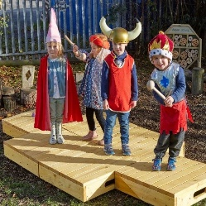
Old scripts/song sheets
Dressing up clothes/old scarves, large shirts etc
Props- blow up mics, guitars etc- anything that could be used in a production…
Wigs
Hats
Old masks

Construction site
Site safety signage
Cones
Tape to cordon off around cones
Hard hats
Hi viz vests
Orange mesh
Construction toys- diggers, mixers etc.
Tarps
Wheelbarrows -small

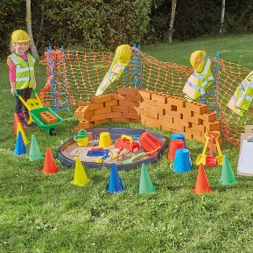

Quiet Area

Small loose parts- milk cartons, egg boxes, cereal boxes etc for creating art
Old colouring books
Markers, pencils etc
Chalk pens
Buckets/containers for hanging on sides of chalk boards
Clipboards
Old wallpaper rolls
Barbies and dressing up clothes
Hooks for hanging colouring bags on.
Old lego
Books
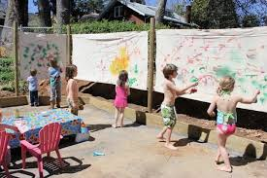
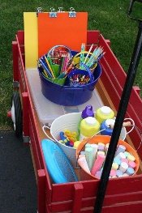

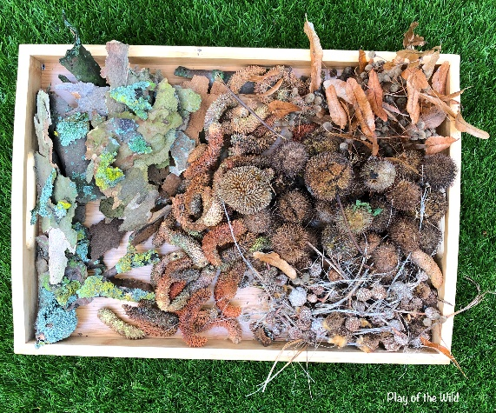
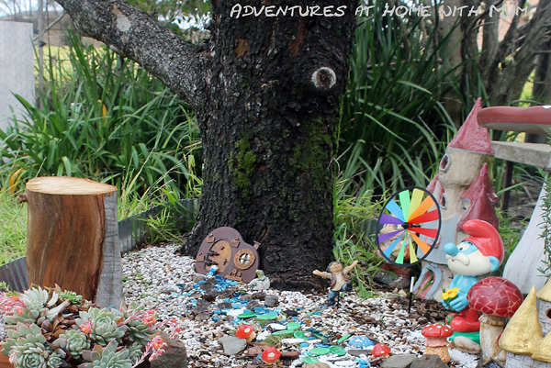
Small world play- located on woodlands/grassy area, already some fairy ornaments etc in place)
Large lidded bin- can be used for storage of items
Tesco crates
Dry twigs/sticks
Acorn/pine cones
Small log slices
Small world toys (e.g. McDonald’s figures etc)
Farm animals
Gnomes
Fairy doors

Mud Kitchen (one in FS yard and one on KS2 yard area) All items can be stored in shed KS1 and KS2 kitchen
Pots/pans
Wooden spoons
Serving utensils
Old serving dishes/trays
Bottles
Sauce bottles
Signage | 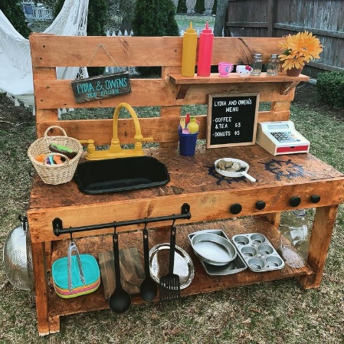
Recipe Books

Other items for upkeep of outdoor play area
- Paint for fences
- Paintbrushes

